SELF DECLARATION FORM

For Exemption Under Sec 80EEA

I Mr.______________Ritam Mukherjee___________________________

Emp No._________________212701861________________________ hereby declare that.

1) I do not own any residential house property on the date of sanction of the loan, this is my first house.

2) Loan Sanction date …04…/…Aug……/……2015…..
*(For exemption loan must be sanctioned during the period from 1st April, 2019 to 31st March, 2020)

3) Home Loan sanctioned amount is ……… 13.5Lac……………….
*(For exemption loan sanctioned amount should not exceed Rs. 45 Lacs)

4) The value of house property (Registered value) …………17 Lac……………..

I also undertake to indemnify the Company in case any liability arises out of dis-allowance of any of the above exemption based on this declaration.

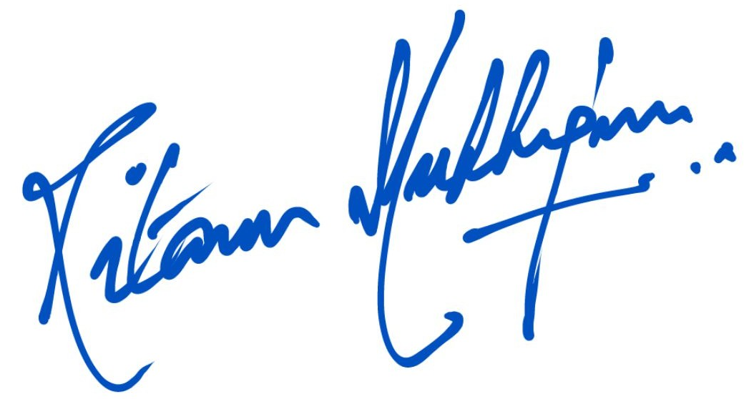

Date: (SIGNATURE OF THE EMPLOYEE)

